COLD ASHBY VILLAGE (memorial) HALL
Main Street, Cold Ashby NN6 6EL
Charity number 1024816
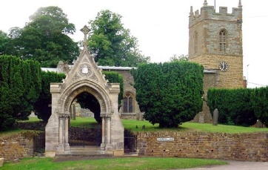
Annual General Meeting

Tuesday November 20th 2018, 7.30 p.m.

Agenda

1.To elect/agree a chairman for the meeting (if the committee chairman is present, he will assume the chair).
2. Attendance: to record those present at the meeting.
3. Apologies
4. To elect a committee in accordance with the trust deed to act until the next annual general meeting. 4 elected members plus one each to represent and elected by the Bowls Club, The Parish Council and the Parochial Church Council
5. Minutes of the 2017-18 AGM
6. Matters arising from the minutes
7. Chairman's report
8. secretary/treasurer's report
9. Adoption of accounts for year 2017/2018
10. Open forum
The AGM will be followed by a meeting of the newly elected committee which will choose the chairman and officers for 2018-19. (see over for agenda)

G Jones, Secretary November 2018

Cold Ashby (memorial) Village Hall

Committee meeting 8 p.m. 20 November 2017
Agenda
- Election of officers for 2018-19
- Chairman
- Secretary
- Treasurer
- Chairman’s report
- Treasurer’s report for November 2018
- Electrics bid to windfarm
- Any other urgent business
G Jones, sec. November 2017

